**Requirements Specification**

Navjot Singh Virk, Student Number: X13112406, Software Development Stream 4th Year

****Project Name: MeetingRoom Pro

Github: <https://github.com/Virksaabnavjot/MeetingRoom-Pro>

Website: <http://roomassistant.navsingh.org.uk>

Documentation: [Github Repository here](https://github.com/Virksaabnavjot/RoomAssistant-Documentation-Repo)

**Table of Contents**

1 Introduction 1

1.1 Purpose 1

1.2 Project Scope 1

1.3 Definitions, Acronyms, and Abbreviations 3

2 User Requirements Definition 3

3 Design Thinking for User Requirements Definition 4

4 Requirements Specification 5

4.1 Functional requirements 5

Use Case Diagram System 5

4.1.1 Requirement 1: Easy to Use GUI 5

4.1.2 Requirement 2: List and Find(Search) 6

4.1.3 Requirement 3: Map / Navigation 7

4.1.4 Requirement 4: Geo Location Notifications 8

4.1.5 Requirement 5: User Registration 9

4.1.6 Requirement 6: Booking System 9

4.1.7 Requirement 7: Photo Gallery 10

4.1.8 Requirement 8: Photo Upload 11

4.1.9 Requirement 9: Review 11

4.1.10 Requirement 10: My Meetings (Calendar event/ Reminder of appointment feature) 12

4.1.11 Requirement 11: Call 12

4.2 Non-Functional Requirements 13

4.2.1 Scalability requirement 13

4.2.2 Availability requirement 13

4.2.3 Physical requirement 14

4.2.4 Security and Privacy requirement 14

4.2.5 Reliability requirement 14

4.2.6 Maintainability requirement 14

5 Interface requirements 15

5.1 GUI 15

5.2 Application Programming Interfaces (API) 19

5.3 Database 19

6 System Architecture 19

7 System Evolution 19

# Introduction

## Purpose

The purpose of this document is to set out the requirements for the development of Meeting Room Pro project. That assist users to find meeting rooms among multiple buildings in multiple locations, with ease of use and review rooms and find relevant information about the rooms.

The intended customers of the application are medium to big size corporate organisations with multiple buildings and hundreds of rooms. And educational institutions like universities and colleges. The target users of the application includes but not limited to – company employees (managers, team leads, interns), facilities department, It department and in educational institutes college staffs and students will be major target audience.

The intended audience for this document is myself, potential clients of the project and the academic staff at the National College of Ireland.

## Project Scope

The scope of the project is to develop quality native IOS application allowing the users to use it on their iPads and iPhones. The application shall show the current location of user in a map view which will allow users to see how far they are from the meeting room, also user shall receive notifications, and the app shall also allow booking and availability feature and some other features. Which will attract users and potential client to get involved with the project also form my research I found no product similar to this application exist in the market. And, the project scope is more stronger due to the fact the application works out of the box (*application client can be easily used for any organisation without any prior changes or any dependencies. Only, different .csv files with building and meeting room information tailor the application for any organisation*).

I was involved in several discussions with Manuel Saez, my manager at SAP SE (internship) and my academic supervisor Christina Muntean. To elicit the following requirements

Here is a list of main features of the application:

* The app shall allow the user to book a meeting room while specifying the date and time of the meeting.
* The app should be able to read users device calendar and check if a meeting exists, the user receives a notification.
* The app shall be able to run smoothly on all iPhones and iPads.
* The app shall have responsive GUI / interface which allows the app to function properly and look good and function properly on different screen sizes.
* The system shall have a database in order to store building and meeting rooms information.
* The database shall have the capability to store geo-spatial data.
* The app must make a secure connection with backend the web service using authentication.
* The system shall have a web service to return data in either JSON/XML format, that will be displayed in the app.
* The application shall have a simple web based dashboard to allow the administrator to add more buildings and rooms with ease.
* The application shall be scalable.
* The application shall have Geo location feature so that when a user is within a certain radius of the meeting room or if outside building gets notified through a friendly notification. “Hey you are this close (*approx. location*) to your destination”.
* The application shall have a gallery to showcase photos of the room and an upload feature that allows the users to upload photos of a room which will also be available to other users to see and benefit from.
* The application shall have an expandable map with building drawn as a polygon and room as point and with apple maps most of the buildings have 3d view available which will allow the user to see the building in 3d view and find where the meeting room is located in the building.
* The application shall provide functionality to make a call from the app to key contacts of the meeting room like IT or Facilities department.

The application will be implemented using open-source programming language Swift 3 and Xcode Editor with continuous unit testing. And on the backend, SAP Hana Spatial and a JavaScript based web service.

## Definitions, Acronyms, and Abbreviations

SAP SE – German Multinational Software Company.

NCI – National College of Ireland

SAP Hana – In memory, column oriented RDBMS.

RDBMS - Relational Database Management System.

Hana Spatial – feature of SAP Hana that allows us to store Geo-Spatial Data.

Geo Spatial Data – Data that has geographic positioning information.

GUI – Graphical User Interface

Shall - The term “*shall”* is used in this document to describe features which the system must have.

Should - The term “*should*” is used in this document to describe a feature which the system should have but may not.

Customer – The term “customer” is used in this document in context of potential users and clients.

# User Requirements Definition

The requirements that I have outlined in the project scope section of this document are that of the customer after D-Shop design thinking and several consultations with myself.

The most of user requirements for this project were collected/suggested by potential users during my internship in SAP SE and during the project idea presentation at SAP D-Shop innovation day on 17th and 18th August 2016 through design thinking (*heading 3*). And some were suggested my my manager at SAP SE and some by project supervisor at NCI.

MeetingRoom Pro will be an all-in-one room assistant application that will help users find meeting rooms, view them on map of building and also find relevant information like floor, room type, capacity, which building the room is located in, city, country and number of floors in that building.

The user will not have to register in order to access the app content. However, in order to review, book meeting rooms, and contribute towards gallery, the user will have to register.

Users will complete a standard registration in order to gain full access to the application features. Not only will registered users have access to content and features but will also have the permission to delete, moderate or upload content.

The users can have different account types –

* Guest *(unregistered)* – View Content Permission
* Basic User *(registered user)* – Review rooms and upload photos to gallery permission
* Moderator/Admin – Review, Upload and Delete content permissions

# Design Thinking for User Requirements Definition

Design thinking is a methodology used by designers like myself to solve complex problems and find desirable solutions for clients. Design thinking can help all sorts of organizations uncover new ways of thinking and doing things.

These are the design thinking process that were used during user requirements definition –

**Empathized with Users** – Observed, engaged and tried to understand user requirements.

Because as designer / developer problems we try to solve are rarely ours so we need to understand user first to develop an application for them.

**Defined the problem –** Brought clarity and focus to design space and framed the problem.

**Idea Generation** – Allowed the users to come up with idea, features and functionality they would like to see in the application. Through brain storming and putting ideas on white board.

# Requirements Specification

## Functional requirements

### Use Case Diagram System

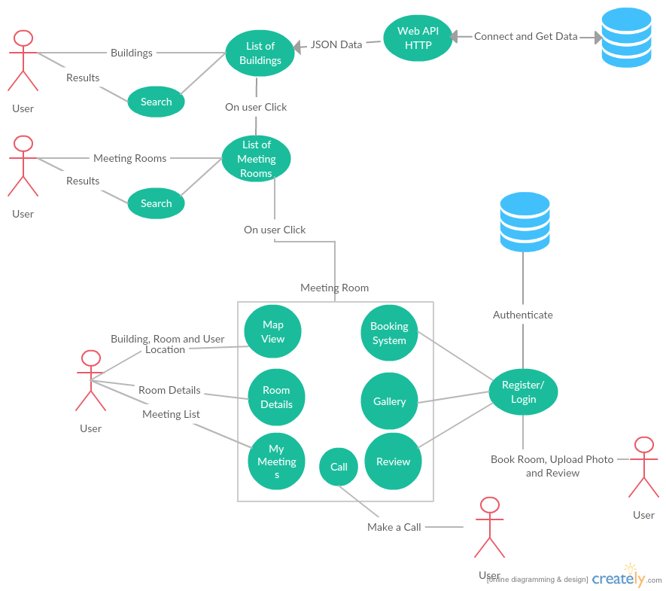

The above Use Case Diagram provides an overview of all functional requirements of this project.

### Requirement 1: Easy to Use GUI

#### User Story

As a user I want to have an easy to use interface so as I can navigate through the app easily with little time needed to be spent learning how to use the app

**Use Case Diagram**

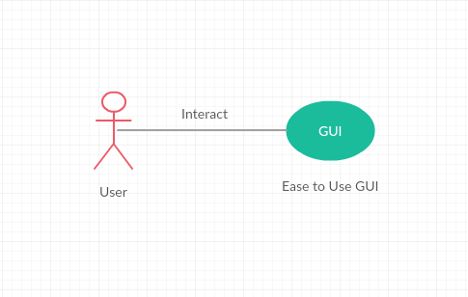

#### Description & Priority

The system shall have an easy to use graphical user interface. Navigation will be possible through the touch screen functionality of the IOS device. The design shall also be responsive so as to support different screen sizes of iPhones and iPads.

*Essential and High Priority Requirement*.

#### Requirement Activation

This requirement will be activated upon starting of the application.

#### Technical Issues

GUI Need internet connection to get data from API which will be shown in the application, slow internet connection can affect performance of the GUI.

#### Risks

Provision must be taking that not all users have a good understanding of technology and the use of mobile platforms. If the GUI is to become too complex, some users may not use the application. This requirement is at the core to the success of the system.

#### Dependencies on other requirements

N/A

### Requirement 2: List and Find(Search)

#### User Story

As a user I want to be able to find buildings and meeting rooms with ease. Like a clickable list of buildings which then browse to list of meeting rooms also search and I can select a meeting room and find it or use other features like room booking, gallery upload etc.

#### Description & Priority

The system shall allow to search and also provide list of available buildings and meeting rooms.

*High Priority*

#### Requirement Activation

The requirement to list buildings and meeting rooms will be activated upon starting of the application and search is activated when user enters in search bar.

#### Technical Issues

N/A

#### Risks

This requirement is at the core to the success of the system as most of the requirements hereafter have a dependency on this one.

#### Dependencies on other requirements

This requirement has a dependency on requirement 1 - Easy to use GUI.

### Requirement 3: Map / Navigation

#### User Story

As a user I want to be able to view the building highlighted on the map. Also the meeting room I am looking for along with my current location and some information about the building and room like floor number.

#### Description & Priority

The system shall have an expandable map with current location of the user and building drawn on the map.

*Optional: The application should leverage some sensors or beacons implemented in the building for effective indoor navigation as GPS may not provide accurate location indoors.*

#### Requirement Activation

The requirement will be activated when the user selects a meeting room from a list of rooms.

#### Technical Issues

N/A

#### Risks

May face some issues with current location of the user while indoors as GPS is not designed for indoors and this may affect the accuracy of the location slightly.

#### Dependencies on other requirements

N/A

### Requirement 4: Geo Location Notifications

#### User Story

As a user I want to have notifications automatically sent to me when within a certain radius of the building or the meeting room so the user is notified that the destination is close enough.

#### Description & Priority

The system shall have functionality that when a user’s smart phone comes within a certain radius of the meeting room a notification will be sent to remind them with approx. distance to the destination i.e. *"Hey,… you are “approx. distance” from your destination ….".* Functionality to unsubscribe to this service should also be provided. *High priority*.

#### Requirement Activation

This requirement will only be activated if a user brings their mobile device which they have the app installed on within a certain radius of the building/meeting room. This distance will be tweaked at the system/ user testing stage of project. This service should also only occur once while finding a meeting room as if a client user was moving in and out of the geographical perimeter they will not receive multiple notifications. As stated above functionality to unsubscribe to this service should also be provided.

#### Technical Issues

N/A

#### Risks

N/A

#### Dependencies on other requirements

N/A

### Requirement 5: User Registration

#### User Story

As a user I shall be able to easily register within seconds to use the advanced features like posting reviews and uploading photos.

#### Description & Priority

The system shall provide a standard registration and login. The requirements like booking and reviewing require registration in order to allow users to use thes features

*High Priority*

#### Requirement Activation

The requirement is activated when user wishes to book, review meeting room and upload photos of the meeting room.

#### Technical Issues

N/A

#### Risks

N/A

#### Dependencies on other requirements

N/A

### Requirement 6: Booking System

#### User Story

As a user I want to be able to book meeting rooms through my smartphone so as I can book meeting rooms easily from anywhere.

#### Description & Priority

Functionality for users to book meeting room once selected a meeting room. This feature shall have its own page and be easy to use i.e. drop down lists to choose data and time of booking and the user shall be able to see the booked meeting rooms.

*High priority*

#### Requirement Activation

This requirement will be activated if the client user wishes to book a meeting room.

#### Technical Issues

N/A

#### Risks

This requirement is very important as some of the requirements hereafter have a dependency on this one.

#### Dependencies on other requirements

This requirement has a dependency on requirement 1 - Easy to use GUI and Requirement 2 – List and Search

### Requirement 7: Photo Gallery

#### User Story

As a user I shall be able to see some photos of the meeting room showing the equipment available and size of room straight from the app.

#### Description & Priority

The system shall have a photo gallery with multiple photos of the room.

*Medium Priority*

#### Requirement Activation

The requirement will be activated when a user selects a meeting room from the list.

#### Technical Issues

N/A

#### Risks

N/A

#### Dependencies on other requirements

N/A

### Requirement 8: Photo Upload

#### User Story

As a user I shall be able to upload some picture from my phone gallery or camera if some pictures are missing in the Gallery.

#### Description & Priority

The system shall allow all registered users to upload images of the rooms to the photo gallery. And also allows users with admins and moderator accounts to delete the low quality images straight from the app.

*High Priority*

#### Requirement Activation

The requirement will be activated when user wishes to upload an image.

#### Technical Issues

N/A

#### Risks

Some users may try to spam or misuse this feature.

#### Dependencies on other requirements

The requirement has a dependency on requirement 7: Photo Gallery

### Requirement 9: Review

#### User Story

As a user I would if there is reviews available about the room and its equipment and also like to review it myself.

#### Description & Priority

The system shall allow the registered users to review meeting rooms based on different parameters like –functionality and quality of available equipment, if the room temperature was good and so on as user feedback will help improve the quality of the meeting rooms and the meeting rooms getting low ratings can be improved and get more attention from IT and Facilities department.

Medium Priority

#### Requirement Activation

The requirement will be activated when the user wishes to review meeting room.

#### Technical Issues

N/A

#### Risks

N/A

#### Dependencies on other requirements

N/A

### Requirement 10: My Meetings (Calendar event/ Reminder of appointment feature)

#### User Story

As a user I would like to see all my meetings and simply see start the map navigation.

#### Description & Priority

The system shall provide a list of meetings booked for the user and the user will receive a reminder notification. The system should be able write and read meetings to and from the device calendar.

#### Requirement Activation

The requirement will be activated when the user has some meetings in their calendar.

Medium to Low Priority

#### Technical Issues

N/A

#### Risks

N/A

#### Dependencies on other requirements

The requirement has dependency on requirement 6: Booking System

### Requirement 11: Call

#### User Story

As a user if I am in a meeting and some equipment is not working I should be able to contact the key contacts for the room that can fix the problem for me. i.e is make a quick call from the app.

#### Description & Priority

The system shall provide contact information for key contacts and allow user to make a call.

#### Requirement Activation

The requirement is activated if the users wishes to make a call through there phone.

#### Technical Issues

N/A

#### Risks

N/A

#### Dependencies on other requirements

Requires a sim card to make calls via the phone.

## Non-Functional Requirements

### Scalability requirement

#### User Story

N/A

#### Description and Priority

With regards to the intended number of users in big and medium cooperate organisation with thousands of employees and teachers and students in educational institutes and the projected load scenarios, the intention is for the system to be able to serve queries in thousands/ day (in large part during the 9-5 peak traffic hours) and the application shall also be scalable to use for any organisation with little to no changes to the app’s code.

*High Priority*

### Availability requirement

#### User Story

As a user I want to be able to access the app at any time I wish.

#### Description and Priority

The app shall be accessible at any time of the day on any day of the year. *High priority*.

### Physical requirement

#### User Story

As a user I want to be able to access the app from anywhere.

#### Description and Priority

The app shall work on mobile devices. *High priority*.

### Security and Privacy requirement

#### User Story

As a user I want the app to be secure like my password must be safe.

#### Description and Priority

The app shall achieve security through encryption and SSL certificate when connecting to the server. *High priority*

### Reliability requirement

#### User Story

As a user I want to the app to be reliable.

#### Description and Priority

The app shall be reliable i.e. stable and consistent of what is expected out of it. *High priority*.

### Maintainability requirement

#### User Story

N/A

#### Description and Priority

# Interface requirements

This section describes how the software interfaces with other software products or users for input or output. Examples of such interfaces include APIs, web services, shared memory, data streams, and so forth. Most systems would have a GUI. Add more subsections for other interfaces as reuired.

## GUI

The app will run on IOS devices that use touch screen functionality. Below is a quick mock up of the GUI for showing the user will interact with it. Displaying an easy to use interface. *Note: These mock ups can be seen abstractions of what will be finally implemented.*

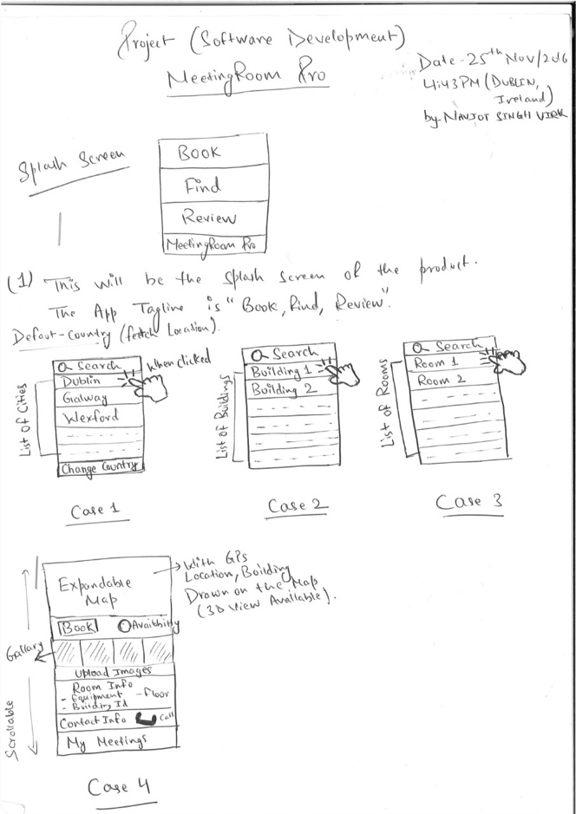

**GUI for the Application**

On starting the application, the user will see Case 1 – List of Countries and Search

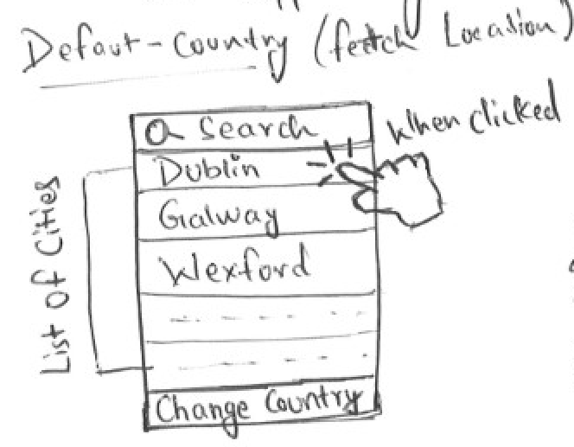

On Click - > Case 2 – List of Buildings and Search

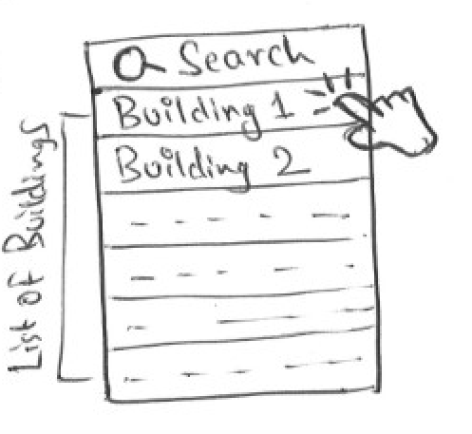

On Click - > Case 3 – List of Meeting Rooms and Search

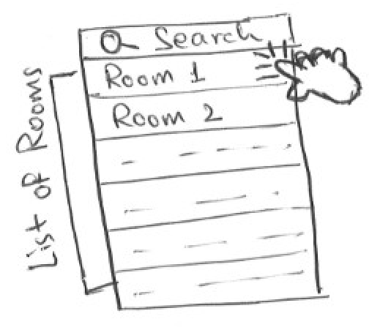

On Click -> Case 4 -> All info about selected meeting room, navigation, map, notifications, room booking system, availability, photo gallery, photo upload, call option and Meeting Rooms

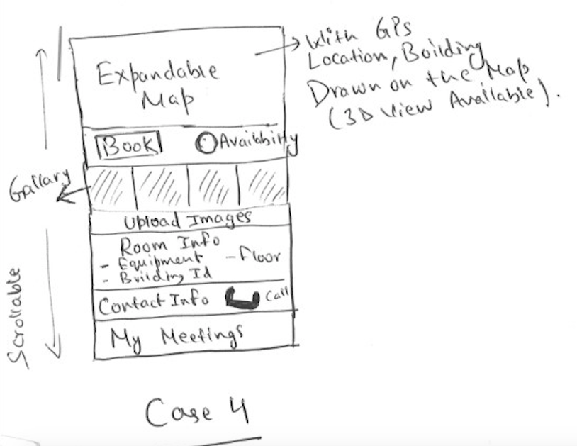

*Note: Please note Case 4 may be broken into further cases when the actual application is developed.*

## Application Programming Interfaces (API)

The following is a list of device APIs which the system will implement:

* Apple MapKit
* Apple CoreLocation
* Apple Foundation
* Apple UIKit
* Apple XCTest
* SwiftyJSON (3rd Party

## Database

The system will interface with a database that stores information about buildings, meeting rooms, users, bookings and photo gallery.

Relational database tables for the following list will be developed:

* Buildings
* Meeting Rooms
* Users
* Bookings
* Reviews
* Photo Gallery

# System Architecture

Use a class diagram to outline the structure of the system. Explain briefly why you have chosen this architecture. You might want to use Visio or Rational Rose to create these.

I have settled on the particular system architecture as to create a consistent and fully functional system. The idea being to create architecture with potential for growth, yet for the system to be fully functional and operative from the beginning.

Users will have the initial option to register or not with the application. With registered users having the opportunity to upload photos, review rooms and book rooms.

# System Evolution

The system can be extended over time as new technologies are introduced. Like aspects of indoor navigation can be brought to the project. The displayed content on the app will continually change, allowing for evolution within the application.

After the app has been in use for a period of time and if successful it may be possible to perform analytics on some of the data been gathered and stored by the app which may be of some benefit to the business. This will be looked at in further detail at a point in the future.